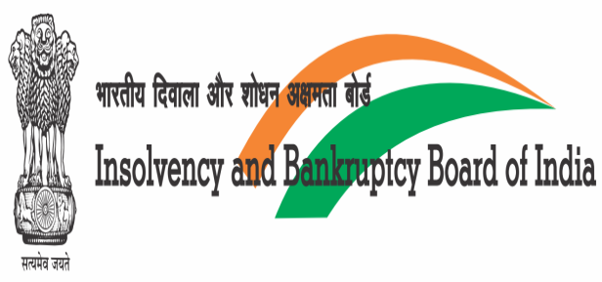 | 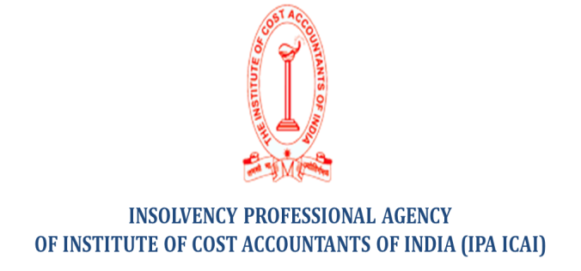

Awareness Program

Insolvency and Bankruptcy Board of India (IBBI) in association with Insolvency Professional Agency of the Institute of Cost Accountants of India (IPA ICAI) is organizing an awareness program on The Insolvency and Bankruptcy Code (Amendment) Ordinance, 2019 and Ease of Doing Business on 15th February, 2020 (Saturday) at Jaipur.
Venue of the Workshop | 3-A, CMA Bhawan, Institutional Area, Jhalana Doongri, Jaipur, Rajathan-302004
Timing | 10:00 AM to 02:00 PM
Fees | Rs.750.00+GST 18%
CPE Hours for IPs | 2 hrs.
Schedule of the Workshop
Time | Particulars
10:00 AM to 10:30 AM | Registration
10:30 PM to 11:00 AM | Tea/Coffee with Cookies
11:00 AM to 11:15 AM | Inaugural Session through Skype
11:15 AM to 11:20 AM | Lightening of the Lamp
11:20 AM to 12:45 PM | Technical Session- The Insolvency and Bankruptcy Code(Amendments) Ordinance, 2019 by Mr. Vishnu Upadhyay
12:45 PM to 01:30 PM | Technical Session- Ease of Doing Business- Mr. Satyendra Khorania
01:30 PM to 02:00 PM | Lunch
End of Program

Confirm your participation via mail at ra2@ipaicmai.in (011-24666113/7678494704) after making the registration fees of Rs. 885/- (Rs. 750/-+ GST 18%) in the under detailed bank account. Please share your IP enrolment number and your NEFT UTR Number.

Beneficiary Name- Insolvency Professional Agency of ICAI
Name of the Bank- Indian Bank (Current Account)
Address of Bank- Defence Colony, New Delhi - 110024
Bank Account No. – 6486054958
IFSC Code- IDIB000D008

