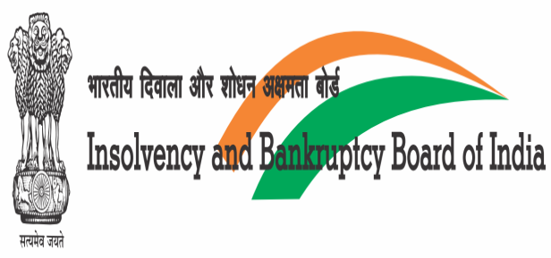 | 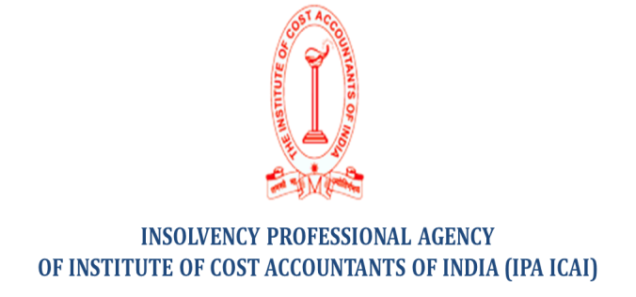

Insolvency and Bankruptcy of Personal Guarantors to Corporate Debtor
&
Liquidation under IBC -Learnings and way forward

Insolvency Professional Agency of the Institute of Cost Accountants of India in association with the Insolvency and Bankruptcy Board of India (IBBI) is organizing an interactive colloquium on Insolvency and Bankruptcy of Personal Guarantors to Corporate Debtor & Liquidation under IBC -Learnings and way forward to discuss the practical challenges met by the professionals on 29th February, 2020 (Saturday) at New Delhi.

Chief Guest: Dr. (Ms.) Mukulita Vijayawargiya, Whole Time Member, IBBI
Venue of the Workshop |  | Sangam Hall, National Productivity Council, Lodhi Road, New Delhi 110003
Timing |  | 02:30 PM to 06:30 PM
Fees |  | Rs. 900.00 (including GST 18%)
CPE Hours for IPs |  | 2 hrs.
CEP Hours for CMAs |  | 2 hrs.
Schedule of the Workshop
Time | Particulars
02:30 PM to 02:50 PM | Registration
02:50 PM to 02:55 PM | Welcome of the Chief Guest and other eminent guests
02:55 PM to 03:00 PM | Welcome Address by Dr. S.K. Gupta, MD & CEO-IPA ICAI
03:00 PM to 3:10 PM | Address by President ICAI, CMA Mr. Balwinder Singh
03:10 PM to 03:30 PM | Address by Dr. (Ms.) Mukulita Vijaywargiya, WTM, IBBI
03:30 PM to 05:00 PM | Technical Session:  “Insolvency and Bankruptcy of Personal Guarantors to Corporate Debtor”  Speaker:  Mr. Vijender Sharma, Insolvency Professional
05:00 PM to 06:00 PM | Panel Discussion:  “Liquidation under IBC-Learnings and way forward..”  Panellists:  Mr. Sushil Behl, Insolvency Professional-Moderator  Mr.Vijender Sharma, Insolvency Professional-Panellist  Mr. G.P. Madaan, Insolvency Professional-Panellist  Mr. Sanjiv Ahuja, Insolvency Professional-Panellist  Ms. Pooja Bahry, Insolvency Professional-Panellist
06:00 PM to 06:30 PM | High Tea

Confirm your participation via mail at ra2@ipaicmai.in (011-24666113/7678494704) after making the registration fees of Rs. 900/- (inclusive of GST 18%) in the under detailed bank account. Please share your IP enrolment number and your NEFT UTR Number.

Please note that as the availability of the seats is limited therefore confirmation of the seats will be on First Come First Serve basis post receipt of the program fee.

Beneficiary Name- Insolvency Professional Agency of ICAI
Name of the Bank- Indian Bank (Current Account)
Address of Bank- Defence Colony, New Delhi - 110024
Bank Account No. – 6486054958
IFSC Code- IDIB000D008

